American Literature and Composition 2017-2018 Syllabus
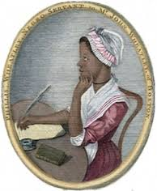
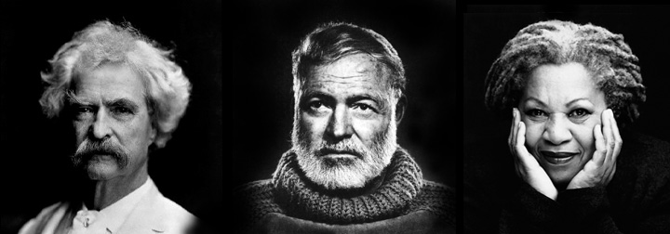

Course Description
American Literature is developed around the Georgia Standards of Excellence to challenge students to develop their critical language skills. Through reading, writing, speaking, and listening; students will explore the intricate components of American Literature’s development, craftsmanship, genres, and other various nuances of American Literature and its relationship to World Literature. Students will explore a gamut of American literary periods that stretch from pre-European Native American oral storytelling tradition into 21st century literature.
The course is comprised of four thematic units, and each thematic unit will focus on one extended text and multiple genres of short readings both literary and informational. Each unit will also focus on critical reading, writing, and thinking skills.

Tentative Course Outline:

1st 9 weeks : “ Personal Growth”

Extended Text: The Crucible

Shorter text: Selected Short stories and poems and informational texts

Selected literary terms and SAT vocabulary

Skills: grammar, analytical writing, close reading and analysis

2nd 9 weeks:
“ Chasing the Dream”

Extended text: The Great Gatsby

Shorter text: Selected Short stories and poems and informational texts

Selected literary terms and SAT vocabulary

Skills: personal narrative, extended and analytical writing (short constructed response), and grammar

3rd 9 weeks: “ Personal Growth”

Extended Text: A Lesson Before Dying

Shorter text: Selected Short stories and poems and informational texts

Selected literary terms and SAT vocabulary

Skills: grammar, analytical writing, close reading and analysis
4th 9 weeks: “ Against All Odds”
Extended Texts: The Glass Castle
Shorter Texts: Selected short stories and poem

Selected literary terms and SAT vocabulary
Skills: grammar, analytical writing, close reading and analysis

Materials and Electronic Resources:

- Literature: Glencoe American Literature textbook If lost or damaged, the replacement cost will be approximately $45.00
- Other reading resources which may be electronic
- Turnitin.com- ALL STUDENTS WILL TURN IN ESSAYS, CONSTRUCTED RESPONSES, AND OTHER WRITINGS THE TEACHER DEEMS NECESSARY INTO TURNITIN.COM. STUDENTS MAY NOT HAND IN A TYPED COPY NOR SUBMIT BY EMAIL. IF A PROBLEM ARISES, STUDENT MUST NOTIFY TEACHER BEFORE THE DAY THAT THE ASSIGNMENT IS DUE AND NOT ON THE DUE DATE. Refer to teacher website and or Google Classroom for information on how to set up a Turnitin account.
- Google Classroom (a web-based resource) will be used as a part of instruction. Students will receive and submit assignments by way of the Google Classroom. Registration for Google Classroom will be on my teacher web page

The student provides:
1. A three ring binder 2-3 inches
2. Tabbed dividers
3. Loose-leaf paper
4. At least 2 black/blue ink pens
5. At least two # 2 pencils
6. Composition book
7. Sticky Notes
8. Colorful pens and highlighters
9. Kleenex

Expectations:
- ALL STUDENTS to give 100 % effort.
- Be in your seat and ready to work before the tardy bell stops ringing
- Bring all necessary materials to class each day. You will not be allowed to leave the room to retrieve any materials that have been left behind.
- Raise your hand when you have something to ask or say.
- Show respect for classmates, teacher, school property, and yourself.
- ALL WORK THAT IS TURNED IN SHOULD BE WRITTEN IN BLUE OR BLACK INK OR PENCIL.
CONSEQUENCES:
1. Warning
2. Call to parent(s)/guardian
3. Detention & parent contact
4. Referral
Make-up work:

1. If you are absent, it is YOUR responsibility to make-up ALL work that you
missed. You will have three class days to make-up missed work after being absent. On the fourth day, your grade will go from an Inc. (incomplete) to a zero.

- Please see me BEFORE SCHOOL OR AFTER SCHOOL about make up work. Make up work will not be discussed during your class period or any other time except for the designated times mentioned previously.

3. It is YOUR responsibility to contact me and set up a time to make-up work
(such as tests that need teacher assistance) either before or after school, NOT during class time. Work NOT made up will be assigned a grade of zero on the fourth day and will not be changed.

4. If you are absent any day before a test or quiz, you are expected to take the test
or quiz on the day it is given because you would have already been aware of
of the date and would have had ample time to prepare.

5. If work is assigned before you are absent (tests, quizzes, homework, etc.), you
must turn in the work on the FIRST day of your return to school unless other arrangements have been made.

Grading System for TCCHS English Department:

40% test grades - unit tests, final drafts, major projects, research papers, etc.

30% quiz grades - vocabulary quizzes, reading content quizzes, rough drafts, etc.

20% daily grades - class work, homework, reading checks, summaries, etc.

10% Benchmark test

- GEORGIA MILESTONES END OF COURSE TEST (EOC) – 20% OF FINAL GRADE

* When graded assignments are returned, you may set up an individual conference with me for an in-depth discussion of the grade(s). Class time will NOT be used for discussion and analysis of individual scores.

Notes:
Please see me with any problem, concern or comment. I am available for help after school with prior notice.

